Vidyarthi Vigyan Manthan Seminar 2025
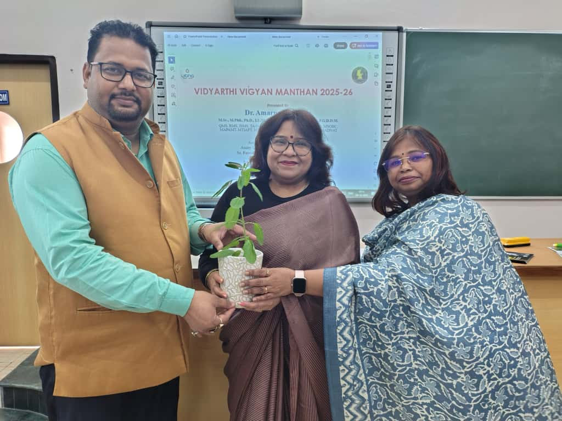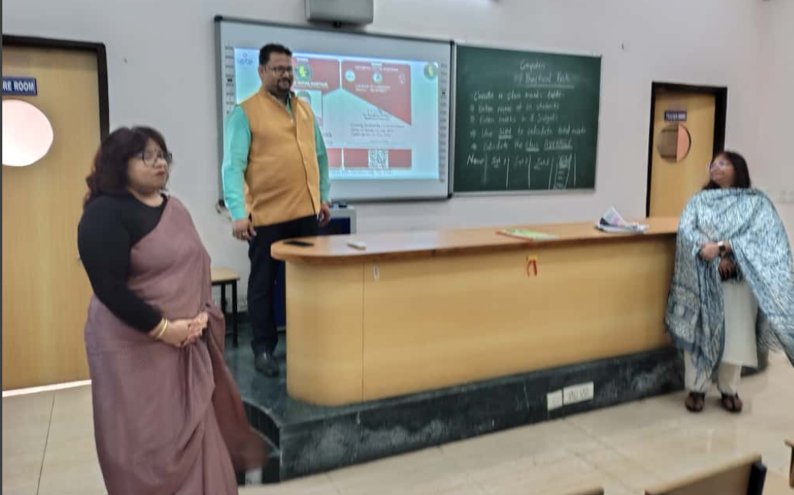
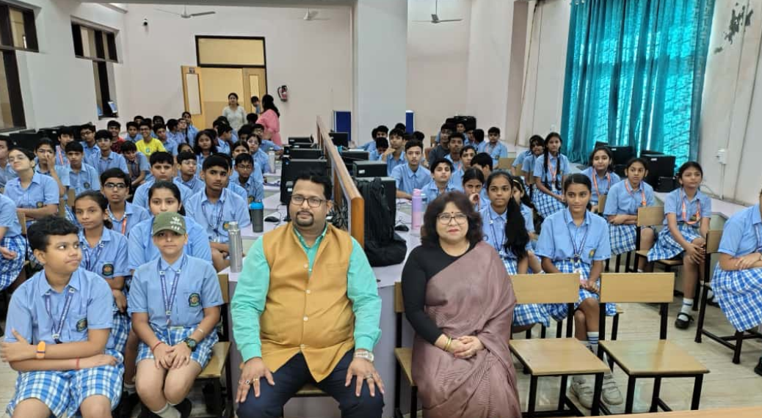

Vishwa Bharti Public School, Ghaziabad believe in inculcating knowledge, imparting manure to the roots to grow with wisdom and intelligence.
On 9/10/25 Dr. Amaranth Mishra ,Associate Professor , Department of Forensic Science,Amity University, Noida visited the campus to deliver a seminar on VVM.
He is an eminent educationist associated with VIBHA,giving his contribution towards awareness and development of Science.

Vidyarthi Vigyan Manthan (VVM) is a science based examination under the initiative of Vijnana Bharati (VIBHA), in collaboration with National Council of Educational Research and Training (NCERT), an institution under the Ministry of Education, Government of India and National Council of Science Museums (NCSM), an autonomous society under the Ministry of Culture, Government of India.

Our school coordinator for VVM,Dr. Garima Wakhle motivated students to participate at large to enhance their skills.

We are thankful to the school management and the principal Mrs. Dimple Puri for their support and guidance.
#vbpsgzb #science #scientist #experiments #vishwabhartipublicschoolghaziabad

