Global Handwashing Day Celebration
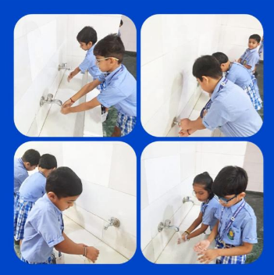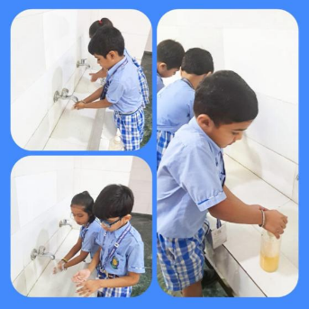
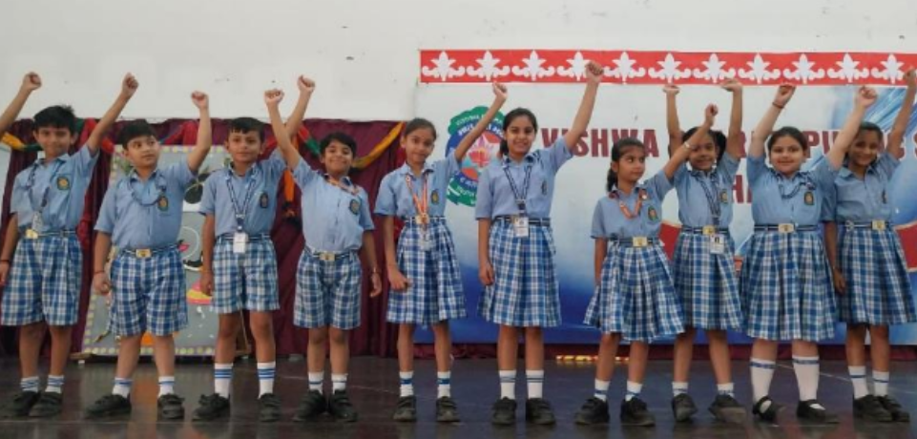
"Clean hands reflect a clean mind and a responsible citizen. Hygiene is the first step towards a healthy and developed nation."
– Inspired by Dr. A.P.J. Abdul Kalam
Vishwa Bharti Public School celebrated Global Handwashing Day on 15 October 2025 with great enthusiasm and awareness. The celebration began with the Gayatri Mantra, followed by the thought of the day, informative facts about hygiene, and news headlines.

Students of Classes IV and V presented speeches, skits, and songs highlighting the importance of hand hygiene and how simple habits can prevent diseases and promote a healthy lifestyle.

In her motivating address, the Principal, Mrs. Dimple Puri, encouraged students to “practice cleanliness, stay healthy, and inspire others to do the same.”

The event concluded with a pledge to maintain personal hygiene, the School Song, and the National Anthem, leaving everyone inspired to keep their hands — and hearts — clean. 🫶🇮🇳

